Project 1 Write-up:

1. **What is the average number of vacant days across the five-year period for QLD social housing?**

This graph shows that the average number of days a property is vacant varies from around 30 days a year to a peak of over 50 days. We can see a steady upward trend until 2019, after which it shows a steady decline. We did not have in-depth data, nor the time, to explore why this could be the case, but we can speculate that housing people was a priority during the pandemic, especially when considering the level of stay-at-home orders we had in Australia.

1. **What was the status of the property during the vacant days (tenantable vs. untenantable)?**

For each year that we have data for, the majority of days that a property was vacant was spent in a status of tenantable. One conclusion that we can draw from this graph with certainty is that there should be a factor that led to the decline of vacancy days.

According to data from the QLD government’s housing reports from 2012 and 2017, the number of properties needed to eliminate the need for a waitlist for social housing would be around 83 000. This graph shows that the average property is ready and available for tenants for an average of 17-34 days, much longer than we would assume is reasonable with the waitlist being around 1.5 to 2 years long according to one news article we found.

1. **How does the number of bedrooms affect the number of vacancy days?**

We found that average number of days a property was vacant fell as the property’s size increased. We later found the data for 5 bedrooms to have a significant outlier, which we assumed to an error with the data entry into the CSV file we found on data.gov.au. After removing this outlier, as well as two other less extreme outliers, our data for the number of bedrooms by vacancy days turned into the graph shown last in this section.

From the context we gleaned from the housing reports, we realised that there is less demand for the properties with 3+ bedrooms, as most people that are in need of social housing are either individuals (49%) or single parents (31%) and yet, these are the properties that are vacant for the longest average time, deepening the housing crisis.

From the second graph, it would be easy to conclude that the average number of vacancy days is affected by the number of bedrooms, the first graph implies that this effect is not a major factor. The second graph may have these results due to a lack of available data for houses with 5 or more bedrooms.

1. **Does the property type affect the number of vacancy days?**

When comparing each of the property types we had data available for, most of the property types followed the same pattern: the wait time for 2 bedroom properties compared to 1 bedroom properties was slightly higher, it then dropped for 3 and 4 bedroom houses. For the final few, there was either no observable pattern or not enough data available to see a trend. The result of this graph makes it seem as though the type of property is not a factor when it comes to how long the property is left vacant.

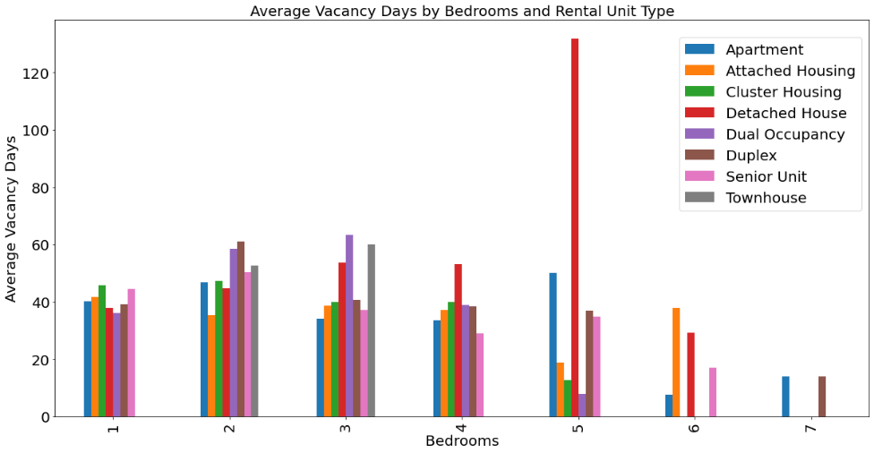

1. **Are there any noticeable factors that affected the trend of vacancy days?**

Upon looking at the COVID case numbers for Queensland briefly, we can a dramatic fall in the average number of vacancy days around July 2020, while the spike in COVID case numbers had a peak in March 2020. We can speculate that this is a delayed reaction to COVID restrictions and government policies to both slow the spread of COVID, as well as reduce the negative impacts of the lockdowns, however, without more data and a much more in-depth investigation, nothing can be concluded with certainty in regards to COVID and the data we have looked at.

Another potential factor could be the results of the housing reports and the promises made in them, such as building more houses and returning the existing houses to the management of community groups, as opposed to government agencies. But again, we are unable to settle on a theory without more data.

